# Network Security Lab Assessment Report

Name: Damilare Oyinloye Emmanuel

Institution: SQI College of ICT

Project: Level 4 NSS Project

## 1. Introduction

This project involved building a controlled virtual lab to conduct a structured network security assessment. The aim was to simulate real-world security testing by identifying live hosts, discovering open ports, enumerating services, detecting operating systems, and assessing vulnerabilities.

## 2. Lab Architecture

Host Machine: Ubuntu Linux (VirtualBox host system)

Attacker System: Kali Linux VM

Target System: Windows VM

Network Design: Internal Network for lab traffic + Host-Only adapter for host interaction

This design ensured a controlled and isolated environment for safe security testing.

## 3. Tools Used

- Nmap (Network scanning and enumeration)

- Linux system utilities (service identification)

- VirtualBox (Virtual lab infrastructure)

## 4. Methodology

Step 1: Host discovery using ping scan to identify active devices.

Step 2: TCP SYN scan to identify open ports.

Step 3: Service and version detection on discovered ports.

Step 4: OS fingerprinting to determine target operating systems.

Step 5: Vulnerability scanning using Nmap NSE vulnerability scripts.

Step 6: Analysis of exposure and security posture.

## 5. Host Discovery Results

Active hosts identified included the Ubuntu host machine, and Windows VM.

## 6. Port Scanning Results

Ubuntu Host: Port 80 (HTTP) was found open.

Windows VM: Host was up, but many ports appeared in filtered or ignored states, indicating firewall filtering. I later disabled the Windows Defender Firewall and discovered ports 135, 139 and 445 in open state. This demonstrates the significance of Windows Defender Firewall in network security.

## 7. Service & Version Detection

Ubuntu Host: Apache2 web server identified running on port 80.

Windows VM (Firewall enabled): Service enumeration was limited due to filtering by Windows Firewall.

Windows VM (Firewall disabled): Microsoft Windows RPC (msrpc) running on port 135, Microsoft Windows netbios-ssn (netbios-ssn) on port 139, and microsoft-ds on port 445.

## 8. Operating System Detection

Ubuntu host detected as Linux-based OS.

Windows VM detected as Microsoft Windows OS.

## 9. Vulnerability Scan Results

Ubuntu Host: No critical vulnerabilities detected via automated scripts. Web checks (XSS, CSRF) returned negative.

Windows VM: Vulnerability checks limited due to filtered ports. Firewall reduces attack surface. Even after the firewall was disabled, no vulnerabilities were found.

## 12. Screenshots Evidence

Screenshots of commands and outputs are included below:

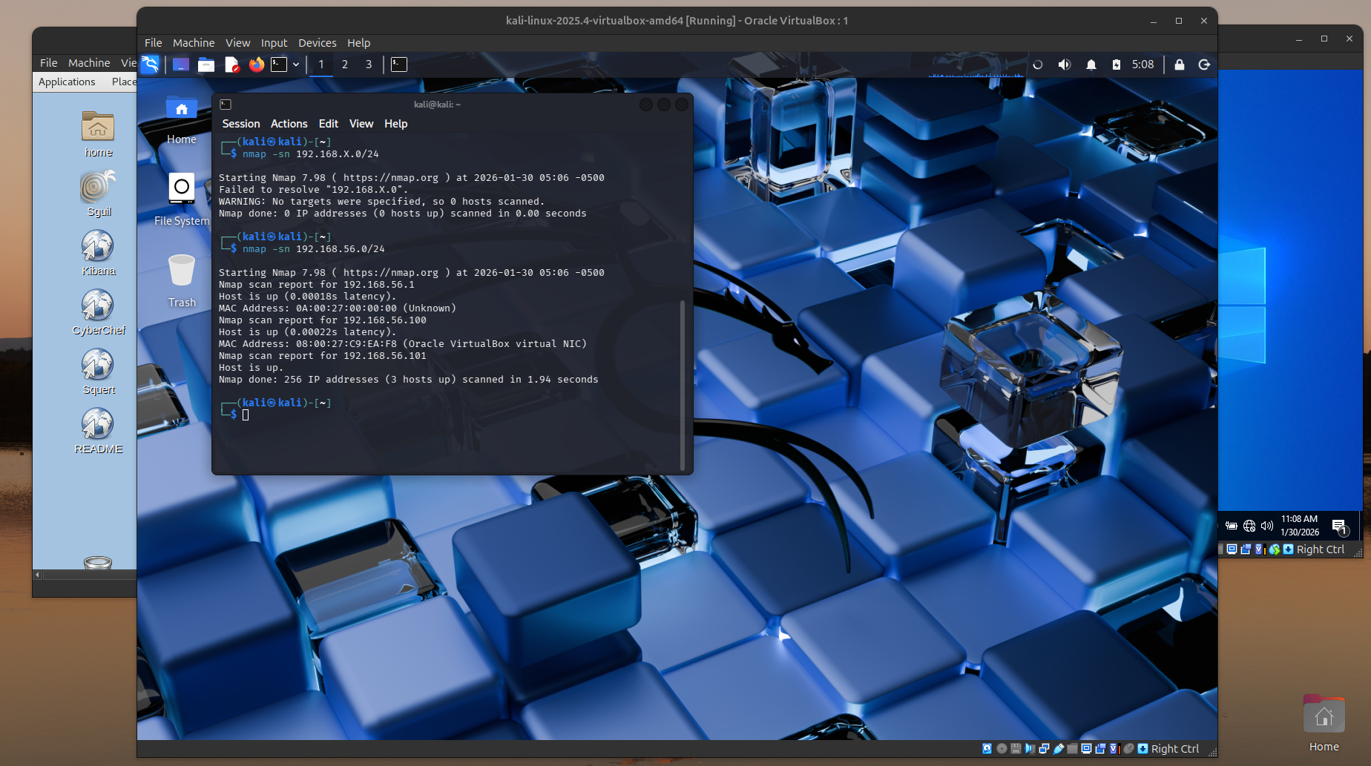

*Figure 1: Nmap Host Discovery Scan Output*

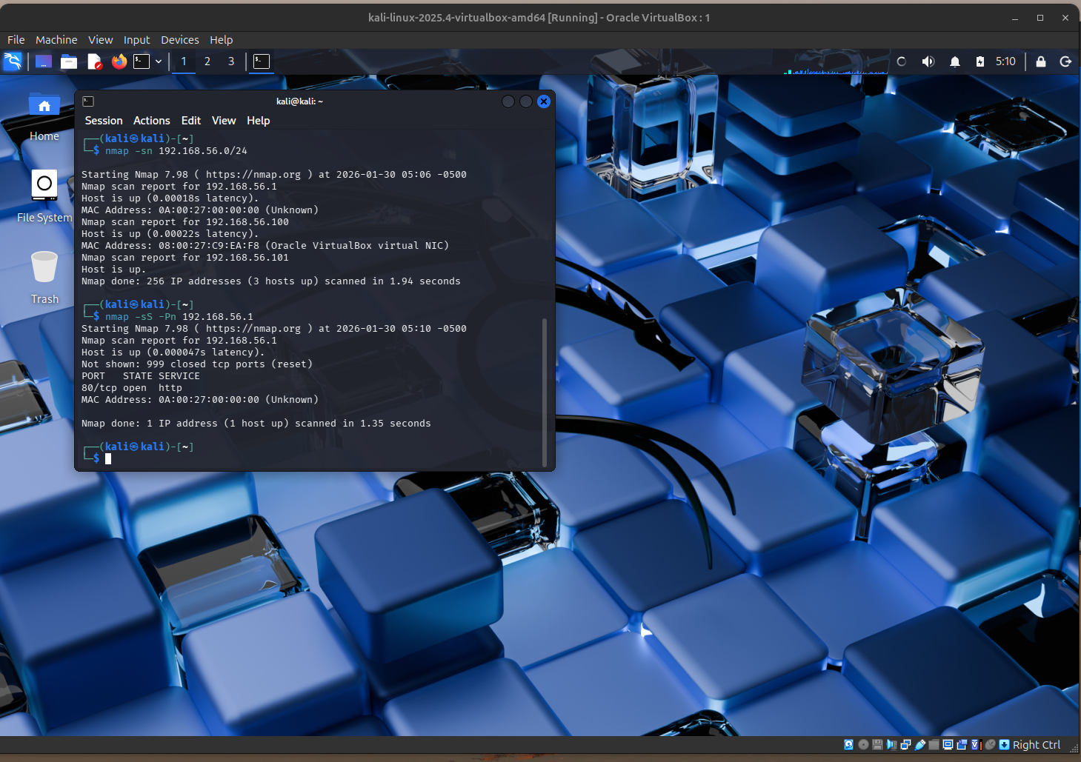

*Figure 2: Nmap Ports Scan Output (Ubuntu)*

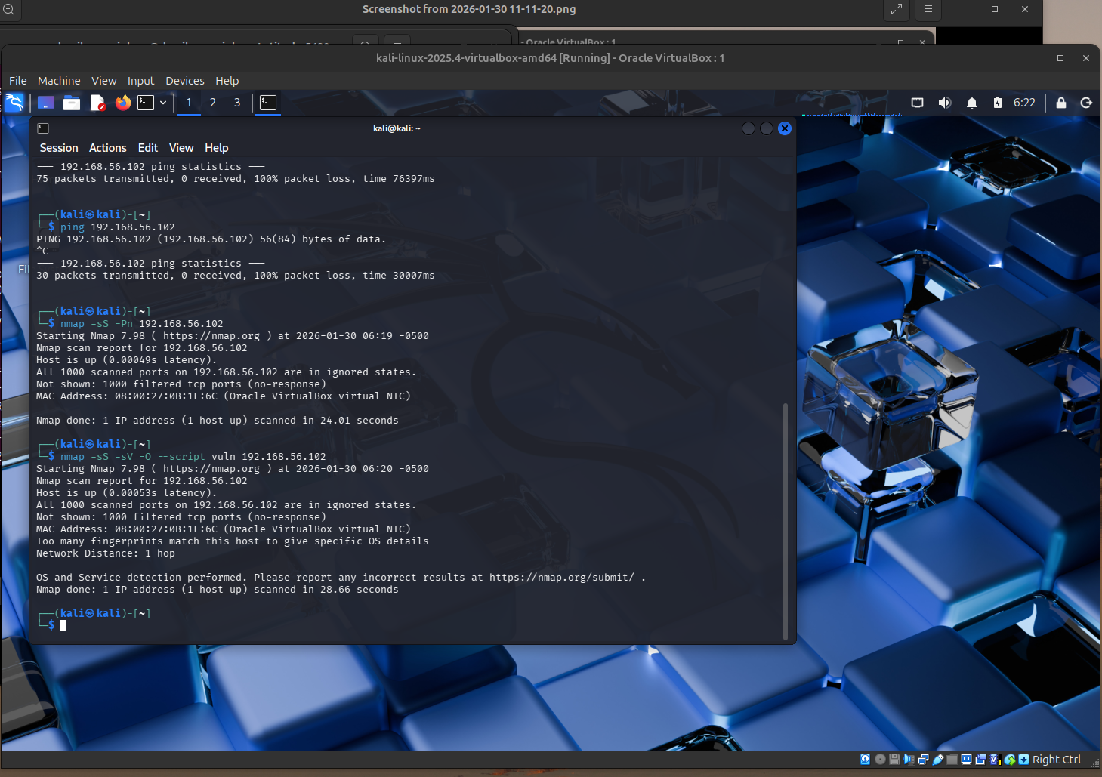

*Figure 3: Nmap Ports Scan Output (Windows under firewall)*

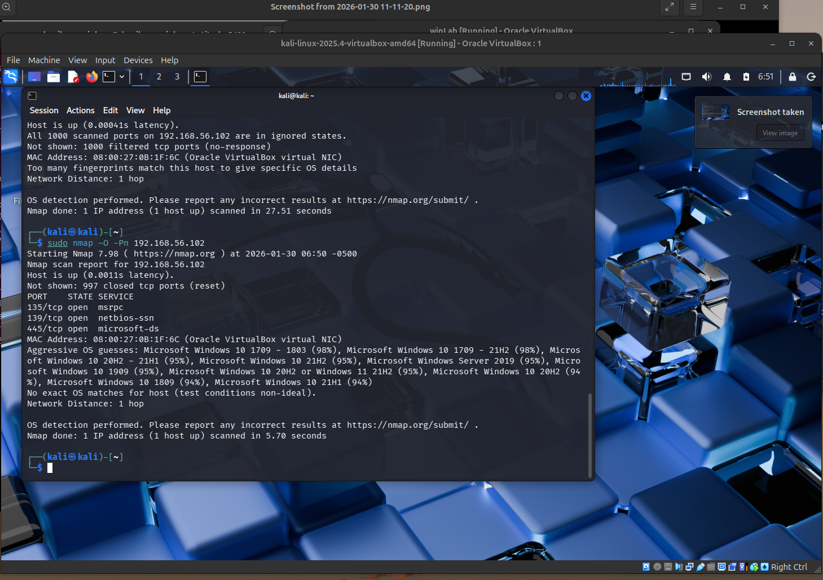

*Figure 4: Nmap Ports Scan Output (Windows firewall disabled)*

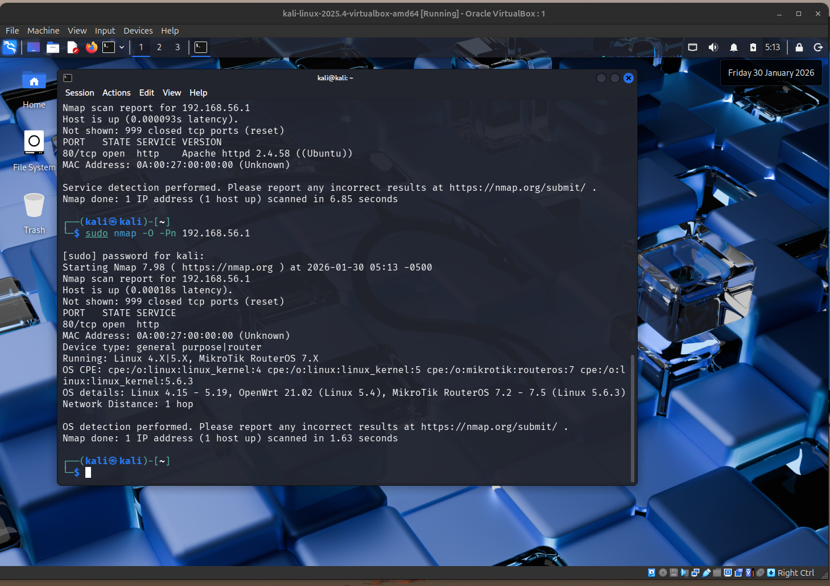

**

*Figure 5 & 6: Nmap OS Detection Output (Ubuntu and Windows)*

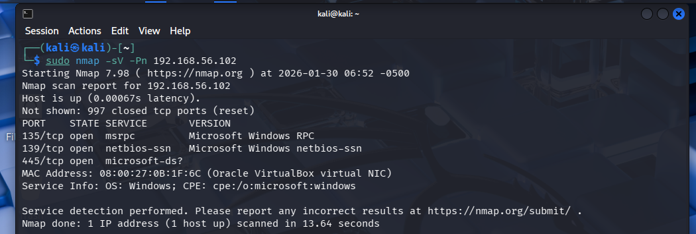

*Figure 5 & 6: Nmap Service/version Detection Output (Windows)*

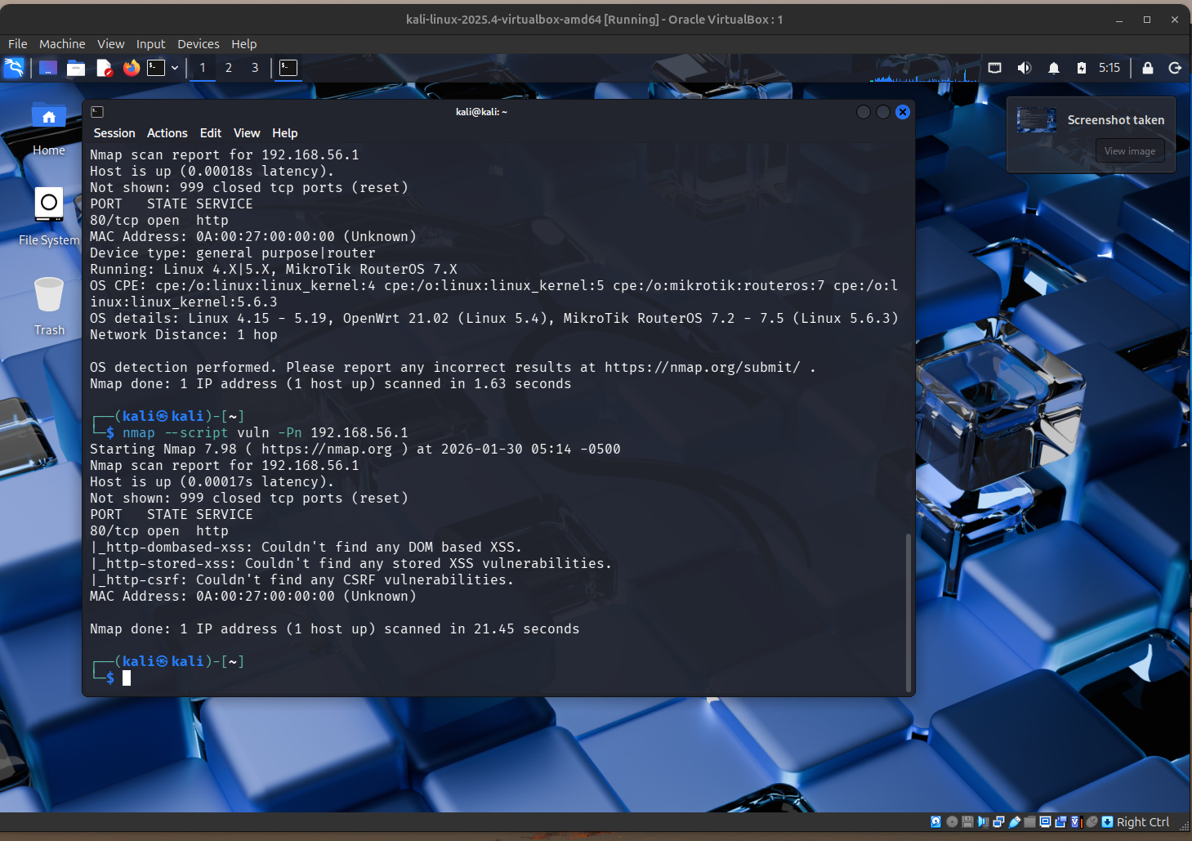

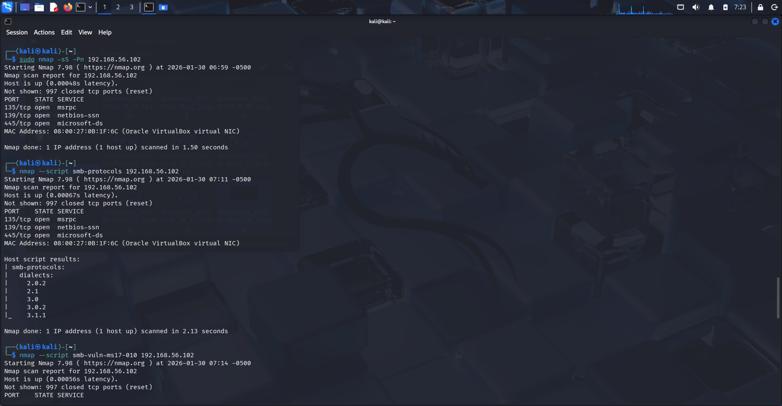

*Figure 7 & 8: Nmap Scan Results (Ubuntu and Windows)*

## 13. Conclusion

## Are the Services Exploitable?

The Windows host exposes SMB, RPC, and NetBIOS services when the firewall is disabled, increasing the attack surface. However, protocol analysis and vulnerability checks did not identify any known exploitable vulnerabilities. The system appears patched and uses modern SMB versions, reducing exploitability. Risk remains due to service exposure but no confirmed remote code execution vulnerability was found.

The project successfully demonstrated practical skills in reconnaissance, enumeration, vulnerability assessment, and security analysis. The lab environment reflected the importance of minimizing exposed services and implementing firewall controls.